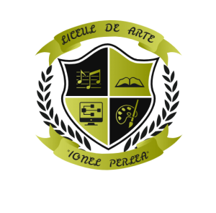
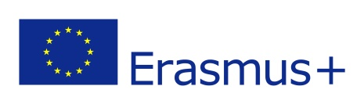
ACT FOR ENVIRONMENT
KA229- School Exchange Partnerships
Project 2020- EL01-KA229-078798

January 2021- Greece- Recycling is the first step
May 2021 – Croatia – Mass consumerism society
November 2021 – Portugal – One week between the river and the sea
February 2022 – Spain – Is our natural heritage in danger?
May 2022 – Romania – Save energy, save environment

DEADLINES
12-14 October – fill in the application documents for the mobilities
www.liceuldearte.ro
19- 23 October – interviews in English (online, Meet)
26-30 October- final results of the mobilities

